|  |  |
| --- | --- |
| **ELECTRONIC ASSIGNMENT COVERSHEET** | Murdoch_land_RGB |

**Kaplan Singapore**

|  |  |
| --- | --- |
| Student Number | Murdoch: 34408441  Kaplan: CT0362378 |
| Surname | Lim |
| Given name | Seng Wei |
| Email | seng.wei.lim@outlook.com |
|  |  |
| Unit Code | ICT 283 |
| Unit name | Data Structures and Abstractions |
| Enrolment mode | PT |
| Date | 3 Mar 2022 |
| Assignment number | 1 |
| Assignment name | Assignment 1 |
| Tutor | Kang Leng |

|  |
| --- |
| **Student’s Declaration:**   * Except where indicated, the work I am submitting in this assignment is my own work and has not been submitted for assessment in another unit. * This submission complies with Murdoch University's academic integrity commitments. I am aware that information about plagiarism and associated penalties can be found at http://www.murdoch.edu.au/teach/plagiarism/. If I have any doubts or queries about this, I am further aware that I can contact my Unit Coordinator prior to submitting the assignment. * I acknowledge that the assessor of this assignment may, for the purpose of assessing this assignment:  -reproduce this assignment and provide a copy to another academic staff member; and/or   -submit a copy of this assignment to a plagiarism-checking service. This web-based service may -   -retain a copy of this work for the sole purpose of subsequent plagiarism checking, but has a   legal agreement with the University that it will not share or reproduce it in any form.   * I have retained a copy of this assignment. |
| I am aware that I am making this declaration by submitting this document electronically and by using my Murdoch ID and password it is deemed equivalent to executing this declaration with my written signature.  Signed LIM SENG WEI    (Write your name in the space above) | |

**Title: ICT283 Assignment 1**

Name: Lim Seng Wei

Class: ICT 283 PT B

1. UML Class Diagram

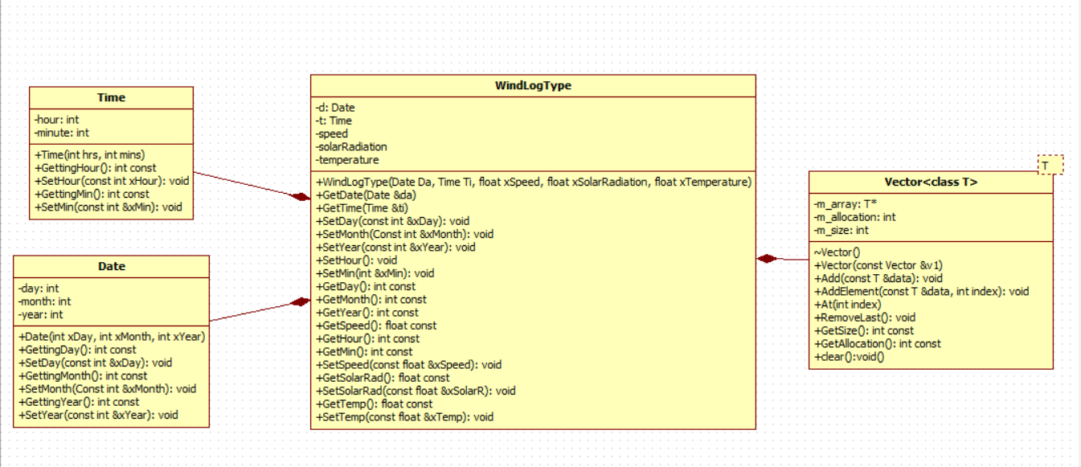

2. Data Dictionary

Design rationale: Have changed windlog struct to a windlog class instead for better encapsulation and future proofing. Getters and setters can all be accessed from main and client has no access to Date and Time class. Have converted each option choice to be part of a function, reading csv into the vector is also converted into a function for a short and simple main().

Date Class

|  |  |  |  |  |
| --- | --- | --- | --- | --- |
| Name | Type | Protection | Description | Rationale |
| Date |  |  | Simulates a date |  |
| day | integer | - | Value of day from a date |  |
| month | integer | - | Value of month from a date |  |
| year | integer | - | Value of year from a date |  |
| Date() | integer | + | Default constructor |  |
| Date(int xDay,int xMonth, int xYear) | integer | + | Constructor to set values |  |
| GettingDay() | integer | + | Getter method |  |
| SetDay(int &xDay) | void | + | Setter method |  |
| GettingMonth() | integer | + | Getter method |  |
| SetMonth(int &xMonth) | void | + | Setter method |  |
| GettingYear() | integer | + | Getter method |  |
| SetYear(int &xYear) | void | + | Setter method |  |

Time Class

|  |  |  |  |  |
| --- | --- | --- | --- | --- |
| Name | Type | Protection | Description | Rationale |
| Time |  |  | Simulates the time |  |
| hour | integer | - | Value of hour from a time |  |
| minute | integer | - | Value of minutes from a time |  |
| Time() | integer | + | Default constructor |  |
| Time(int xHour,int xMin) | integer | + | Constructor to set values |  |
| GettingHour() | integer | + | Getter method |  |
| SetHour(int &xHour) | void | + | Setter method |  |
| GettingMin() | integer | + | Getter method |  |
| SetMin(int &xMin) | void | + | Setter method |  |

WindLogType Class

|  |  |  |  |  |
| --- | --- | --- | --- | --- |
| Name | Type | Protection | Description | Rationale |
| WindLogType |  |  | Simulates a set of data from the data file |  |
| d | Date object | - | Date object | Date class methods are now private, will create getter/setter for its method in this class |
| t | Time object | - | Time object | Time class methods are now private, will create getter/setter for its method in this class |
| speed | float | - | Value of speed from the data file |  |
| solarRadiation | float | - | Value of solar radiation from the data file |  |
| temperature | float | - | Value of temperature from the data file |  |
| WindLogType() | void | + | Default constructor |  |
| WindLogType (Date Da, Time Ti, float xSpeed, float xSolarRadiation, float xTemperature) | void | + | Constructor to set values |  |
| GetDate(Date &Da) | void | + | Getter method | Get the date object, used in output stream overloading in main.cpp |
| GetTime(Time &Ti) | void | + | Getter method | Get the time object, used in output stream overloading in main.cpp |
| SetDay(int &xDay) | void | + | Setter method | Set the value of day into date object |
| SetMonth(int &xMonth) | void | + | Setter method | Set the value of month into date object |
| SetYear(int &xYear) | void | + | Setter method | Set the value of year into date object |
| SetHour(int &xHour) | void | + | Setter method | Set the value of hour into time object |
| SetMin(int &xMin) | void | + | Setter method | Set the value of minute into time object |
| GetDay() | integer | + | Getter method | Return day from date object, used when looping through vector to find specific date |
| GetMonth() | integer | + | Getter method | Return month from date object, used when looping through vector to find specific date |
| GetYear() | integer | + | Getter method | Return year from date object, used when looping through vector to find specific date |
| GetSpeed () | float | + | Getter method |  |
| SetSpeed(float &xSpeed) | float | + | Setter method |  |
| GetSolarRad () | float | + | Getter method |  |
| SetSolarRad(float &xSolarR) | float | + | Setter method |  |
| GetTemp () | integer | + | Getter method |  |
| SetTemp(float &xTemp) | float | + | Setter method |  |

Vector Template Class

|  |  |  |  |  |
| --- | --- | --- | --- | --- |
| Name | Type | Protection | Description | Rationale |
| T\* m\_array | pointer | - | Pointer to vector | Stores the address of vector |
| m\_allocation | integer | - | Storage of the vector | Stores the maximum allocation of the vector |
| m\_size | integer | - | Number of elements present in the vector | Stores the current number of elements used in the vector |
| Vector() | class | + | Default constructor |  |
| ~Vector() | class | + | Destructor |  |
| Vector(const Vector &v1) | class | + | Copy constructor | Deep copying |
| Add() | void | + | Add an element to the next available index | Simulate push function of a vector |
| At (int index) | class | + | Extract element at a specific index of the vector | Allows access to every single element easily and for using in a loop |
| RemoveLast() | void | + | Remove last element from vector |  |
| GetSize() | integer | + | Get the size of the vector, return m\_size | To be used to loop through vector elements that are not empty |
| GetAllocation() | integer | + | Get the allocation/storage of the vector, return m\_allocation |  |
| clear() | void | + | Set vector to size 0 |  |

4. Algorithm

This program reads data from a CSV and is able to perform a few functions with the data acquired

Main {

Create an array of string to store all 12 months of a year, size 13

Create an array of double to store speed,temperature,solar radiation individually, where the month of the date will be the index of the array, size 13

Create a vector of <WindLogType> windlog

Create a vector of <string> column

Create object of windlog

Open file for reading

Store the first line of header information into <string> vector

Store each remaining line into WindLogType vector using setters and delimiters as comma

Use for loops to skip unneeded columns and don’t store into the vector

Add each windlog object into the vector

While loop{

Display Menu with 5 options

Option 1:

Ask user for input

For loop through the vector{

If(userinput == year && userinput == month)

Add all the instances of speed together

Add all the instance of temperature together

Add 1 to the counter for each loop

Convert total speed to be in km/h

Calculate average speed, total speed divide by counter

Calculate average temperature

if(average speed and average temperature !=0)

Output average speed and average temperature

}

Option 2:

Ask user for input

For loop through the vector{

if(userinput == year)

Extract every data that matches the year and save them into the array using the month as the index

Calculate total and average speed

Calculate total and average temperature

Convert speed to km/h

Add 1 to the counter for each loop

}

For loop 12 times starting from index 1{

if(average speed and average temperature !=0)

output the month using month array

output average speed and average temperature using their array

}

Option 3:

Ask user for input

For loop through the vector{

if(userinput == year)

if(solarRadiation >=100)

calculate total solar radiation

convert solar radiation to be kWh/m2

}

For loop 12 times starting from index 1{

if(total solar radiation !=0)

output month and the total solar radiation

if(total solar radiation ==0)  
output “No Data”

}

Option 4:

Boolean fileWritten = false;

Ask user for input

Open file for writing

For loop through the vector{

if(userinput == year)

Extract every data that matches the year and save them into the array using the month as the index

Calculate total and average speed

Calculate total and average temperature

Convert speed to km/h

Add 1 to the counter for each loop

}

if(solarRadiation >=100)

calculate total solar radiation

convert solar radiation to be kWh/m2

For loop 12 times starting from index 1{

if(total solar radiation !=0, total speed !=0, total temperature !=0)

write to CSV

fileWritten = true;

}

if(fileWritten == false)

output “No Data”

Option 5:  
exit the program

5. Testing

Date Class

|  |  |  |  |  |
| --- | --- | --- | --- | --- |
| **Test ID** | **Description** | **Input** | **Expected output** | **Pass/Fail** |
| 1 | Test default constructor initialize correctly | Date d1; | 0/0/0 | Pass |
| 2 | Test Getter for day | d2.GettingDay() | 3 | Pass |
| 3 | Test Getter for month | d2.GettingMonth() | 3 | Pass |
| 4 | Test Getter for year | d2.GettingYear() | 2033 | Pass |
| 5 | Test Setter for day | d3.SetDay(22) | 22 | Pass |
| 6 | Test Setter for month | d3.SetMonth(2) | 2 | Pass |
| 7 | Test Setter for year | d3.SetYear(2022) | 2022 | Pass |

Time Class

|  |  |  |  |  |
| --- | --- | --- | --- | --- |
| **Test ID** | **Description** | **Input** | **Expected output** | **Pass/Fail** |
| 1 | Test default constructor initialize correctly | Time t1; | 0:00 | Pass |
| 2 | Test Getter for hour | t2.GettingHour() | 23 | Pass |
| 3 | Test Getter for minute | t2.GettingMin() | 59 | Pass |
| 4 | Test Setter for hour | t3.SetHour(1) | 1 | Pass |
| 5 | Test Setter for minute | t3.SetMin(59) | 59 | Pass |

WindLogType Class

|  |  |  |  |  |
| --- | --- | --- | --- | --- |
| **Test ID** | **Description** | **Input** | **Expected output** | **Pass/Fail** |
| 1 | Test default constructor initialize correctly | WindLogType w1 | 0 for all 5 attribute | Pass |
| 2 | Test Getter for day | w1.GetDay() | 2 | Pass |
| 3 | Test Getter for month | w1.GetMonth() | 2 | Pass |
| 4 | Test Getter for year | w1.GetYear() | 2022 | Pass |
| 5 | Test Getter for hour | w1.GetHour() | 23 | Pass |
| 6 | Test Getter for minute | w1.GetMin() | 59 | Pass |
| 7 | Test Getter for speed | w1.GetSpeed() | 10 | Pass |
| 8 | Test Getter for solar radiation | w1.GetSolarRad() | 20 | Pass |
| 9 | Test Getter for temperature | w1.GetTemp() | 30 | Pass |
| 10 | Test Setter for day | w1.SetDay(11) | 11 | Pass |
| 11 | Test Setter for month | w1.SetMonth(1) | 1 | Pass |
| 12 | Test Setter for year | w1.SetYear(2011) | 2011 | Pass |
| 13 | Test Setter for hour | w1.SetHour(14) | 14 | Pass |
| 14 | Test Setter for minute | w1.SetMin(30) | 30 | Pass |
| 15 | Test Setter for speed | w1.SetSpeed(20) | 20 | Pass |
| 16 | Test Setter for solar radiation | w1.SetSolarRad(30) | 30 | Pass |
| 17 | Test Setter for temperature | w1.SetTemp(40) | 40 | Pass |

Vector Template Class

|  |  |  |  |  |
| --- | --- | --- | --- | --- |
| **Test ID** | **Description** | **Input** | **Expected output** | **Pass/Fail** |
| 1 | Test default constructor initialize correctly | Vector<int>test1 | blank | Pass |
| 2 | Test Add | test1.Add(100) | 100 | Pass |
| 3 | Test Add element | test1.AddElement(200,0) | 200 | Pass |
| 4 | Test At function | test1.At(0)  test1.At(1)  test1.At(2) | 1  10  20 | Pass |
| 5 | Test remove last | test1.RemoveLast() | Vector size reduce from 3 to 2 | Pass |
| 6 | Test Get size | test1.GetSize() | Return current size of 2 | Pass |
| 7 | Test Get allocation | test1.GetAllocation() | Return current allocation of 5 | Pass |
| 8 | Test clear | test1.clear() | Size reduced to 0, GetSize() returns 0 | Pass |

Main Class, tested using MetData\_Mar01-2015-Mar01-2016-ALL.csv

|  |  |  |  |  |
| --- | --- | --- | --- | --- |
| **Test ID** | **Description** | **Input** | **Expected output** | **Pass/Fail** |
| 1 | Test option 1 with valid input | 5  2015 | Shows average windspeed and temperature | Pass |
| 2 | Test option 1 with invalid input | 13  14 | Output no data message | Pass |
| 3 | Test option 2 with valid input | 2015 | Show monthly windspeed and temperature for the whole year | Pass |
| 4 | Test option 2 with invalid input | 1993 | Output no data message for each month | Pass |
| 5 | Test option 3 with valid input | 2015 | Show monthly solar radiation for the whole year | Pass |
| 6 | Test option 3 with invalid input | 1993 | Output no data message for each month | Pass |
| 7 | Test option 4 with valid input | 2015 | Output message file written to CSV | Pass |
| 8 | Test option 4 with invalid input | 1993 | Output no data, file written to CSV | Pass |
| 9 | Test option 5 | 5 | Exit program | Pass |
| 10 | Enter invalid option at menu | 6 | Output error message | Pass |

Test ID 1:

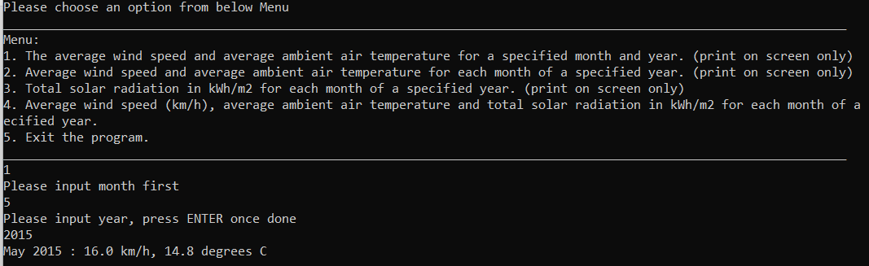

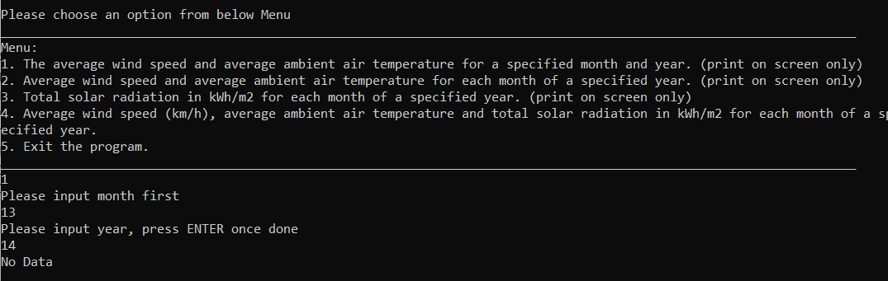Test ID 2:

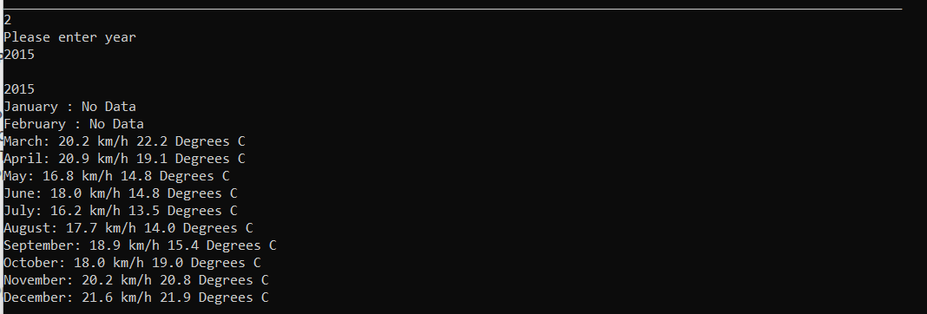Test ID 3:

Test ID 4:

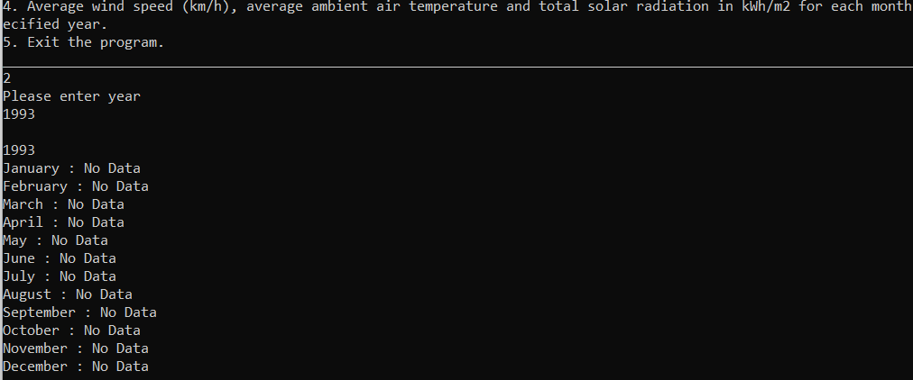

Test ID 5:

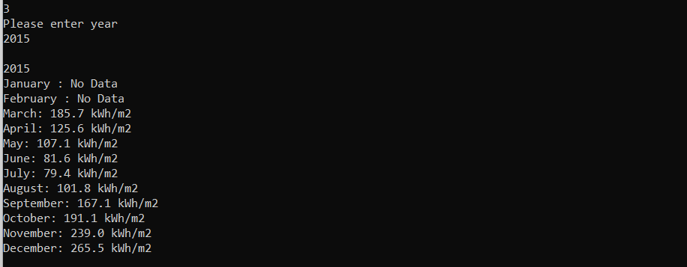

Test ID 6:

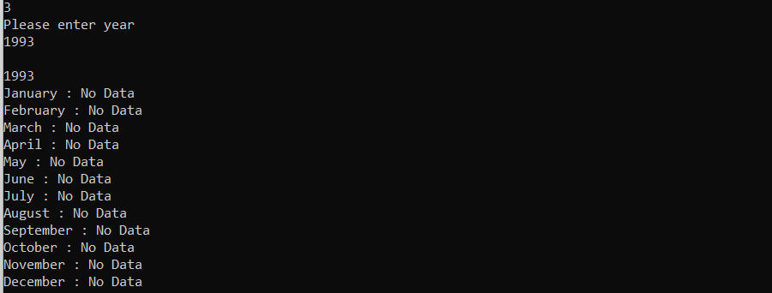

Test ID 7:

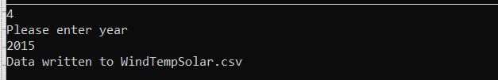

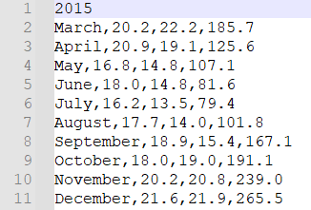CSV:

Test ID 8:

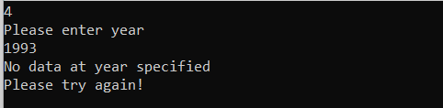

CSV:



Test ID 9:

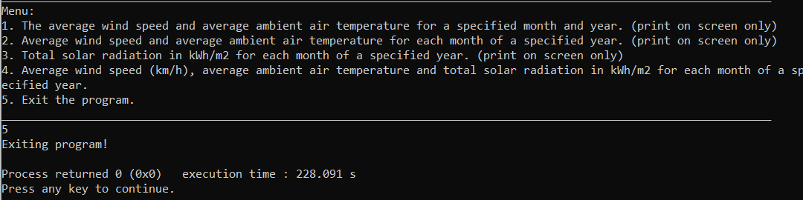

Test ID 10:

